Use Find and Replace to Personalize This Story

aaa | Your First Name
bbb | Your Home Town
ccc | Your Age
ddd | Your Favourite Activity (football, watching TV, etc.)
eee | Your Favourite Toy
fff | Your Best Friend’s First Name
ggg | Your Favourite Treat (sweets, biscuits, ice cream, etc.)

North Pole Christmas Party
aaa had just taken a bath and was ready for bed. What was that note laying on the pillow? It wasn’t there before aaa went to take a bath.
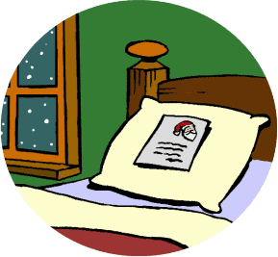
Dear aaa,
You’re invited to a Christmas party at Santa’s Secret Village!
If you can come, go sit by your Christmas tree tonight and think of me!
- Santa

An invitation to Santa’s Christmas party! aaa could hardly believe it. “I must be the luckiest kid in bbb! I wonder if all the elves and reindeer will be there?”
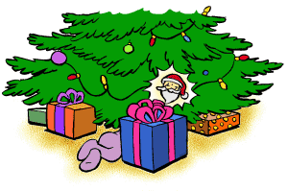
aaa waited until everyone else in the house was asleep, then tiptoed from the bedroom to the Christmas tree. Sitting down, aaa looked at the ornaments and concentrated on Santa Claus. Even though the lights were off in the room, there was moonlight outside, enough to give a sparkle to the shiny Santa ornament on the bottom branch.
The ornament began to jiggle, and aaa could hear laughter from a distance. The lights on the tree came on and got very bright. aaa wasn’t afraid. No, aaa knew the party was about to begin!
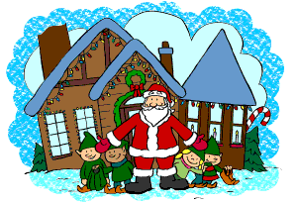
“Welcome to Santa’s Secret Village!” boomed a cheerful voice. “I’m so glad you’re here!” The elves crowded around aaa, bringing a warm coat, mittens, shoes and even an elf hat.
aaa had never seen a more beautiful sight. The village looked like a fantasyland. The buildings were loaded with Christmas lights and other decorations. Christmas songs played, elves were dancing, and the reindeer were prancing around to the music.
“Mrs. Claus and I are giving this party to thank the elves and reindeer for their hard work preparing for Christmas Eve,” said Santa. “We wanted you to join us as our honorary elf because you’ve worked hard and been so good all year!”
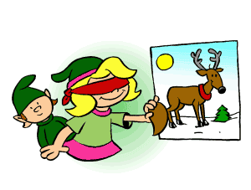
Soon everyone was laughing and happily playing games. Their first game was “Pin the Tail on the Reindeer.” Bonnie was the first one to be blindfolded. Santa gave her the “tail” and turned her around. She went straight away from the reindeer poster and pressed the “tail” on Santa!
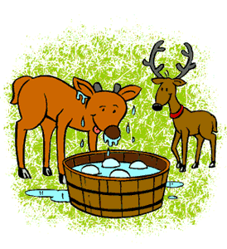
Everyone laughed, even the reindeer, who were good sports about the game—after Santa assured them the “tail” was made of paper and would be attached with tape and not pins!

Their next game was bobbing for frozen snowballs. The reindeer loved frozen snowballs, and they were quite willing to dunk their faces in the water for such a treat!
“Oh, Raymond,” laughed Santa, “you look so funny! You’ve played in the water so long you’re going to have icicles hanging from your face!” Raymond was the youngest reindeer in the village, and aaa, who was ccc, liked him a lot.
“Let’s take a break from the games and go see what Mrs. Claus has prepared for us,” said Santa.
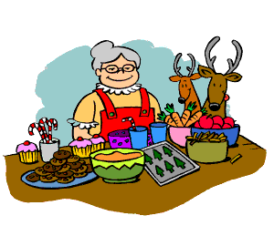
Bud and Bonnie walked with aaa to the food tables, which were loaded with lots of delicious treats. There were lots of things aaa had back in bbb—Christmas cookies, hot cocoa, candy canes and apples and carrots, which the reindeer went for first. Mrs. Claus even had aaa’s favorite, ggg!
There were some surprises, too—kringle fries, northpole nachos, snowcream pudding, and Santa shakes! Everything was so yummy! They all ate and ate, until Santa laughed and told the reindeer if they kept eating they’d be too heavy to fly!

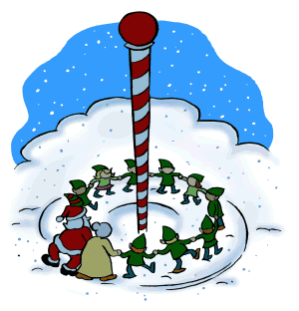
Their next game was “Ring Around the North Pole.” Santa, Mrs. Claus, aaa and the elves joined hands and circled around the North Pole in the center of the village. They skipped around in one direction, and when the music stopped, changed directions and skipped the other way. Each time the music restarted, it played faster. They laughed and skipped and turned until they fell in the snow, dizzy and laughing!
To aaa, fun usually involved eee or ddd, but being here was especially fun. aaa was so happy!
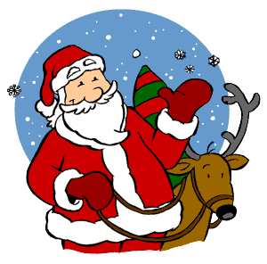
And so were the reindeer, who had gone back to look for more frozen snowballs.
Since they were already in the snow, they decided to make snow angels. Back in bbb, aaa and fff had talked about playing in the snow just yesterday.
Suddenly it began to snow. “Fresh snow for Christmas!” cried the elves. They all jumped up excitedly.
“It’s time for our party to end now,” said Santa. “aaa, it may be snowing at your house, too, and you can play in the snow with your friends. One of my reindeer will take you home.” He put aaa on top of a reindeer, and said, “Hold tight, close your eyes, and you’ll be home in a flash!”
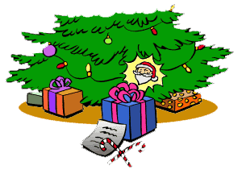
aaa blinked hard and looked around. There was the Christmas tree. The lights were off, but there was still enough moonlight to see. The Santa ornament was very still. And underneath it, on the floor, were a note and two big candy canes!

Happy and tired, aaa picked up the note and the candy canes and tiptoed back to bed. Yes, thought aaa, it already was a very Merry Christmas.
aaa, I’m so glad you came to my party! Here’s a little treat for you, and your friend fff, too.
Have a very Merry Christmas!
Your friend,
Santa

THE END!

